**DataViz 2025**

**Submitted By –** Shivam Pant

**Dataset Link** - [Mental_Health_dataset](https://drive.google.com/file/d/16sG2JU0O0e3MmStuLKVXO1Ln2ObUnCLK/view?usp=sharing)

**Dataset Description:**

The dataset used in this analysis provides insights into various demographic, lifestyle, and mental health factors. It includes data on:

* Age, gender, and employment status.
* Sleep hours and their variations across age groups.
* Mental health indicators such as anxiety and depression scores.
* The impact of family history and chronic illness on mental health.
* Social support, substance use, and their relation to mental well-being.

**Key Insights Extracted:**

**1. Demographic Overview**

* The average age of participants is **46** years.
* The gender distribution shows **47.42% Female**, **43.33% Male**, with the remainder identifying as Non-Binary or Other.
* **31.83% of participants have a family history of mental illness**.
* Employment status varies significantly with age, showing trends of student life, employment, retirement, and unemployment.
* Sleep patterns fluctuate with age, with an average of **6.5 hours per night**.

**2. Mental Health Insights**

* The **average Anxiety Score is 10.47**, while the **average Depression Score is 10.67**.
* Mental health scores differ across gender, with noticeable variations.
* **Family history of mental illness correlates with higher anxiety and depression scores**.
* A radar chart highlights the impact of different mental health factors.

**3. Lifestyle & Well-Being**

* **Substance use is categorized into None, Occasional, and Frequent, showing a clear mental health impact**.
* **Higher social support scores are linked to lower anxiety levels**.
* Employment status impacts mental health, with unemployment correlating with higher stress and anxiety levels.
* Self-esteem, life satisfaction, and mental health show a clear interrelation in a comparative analysis.

**Dashboard Screenshots:**

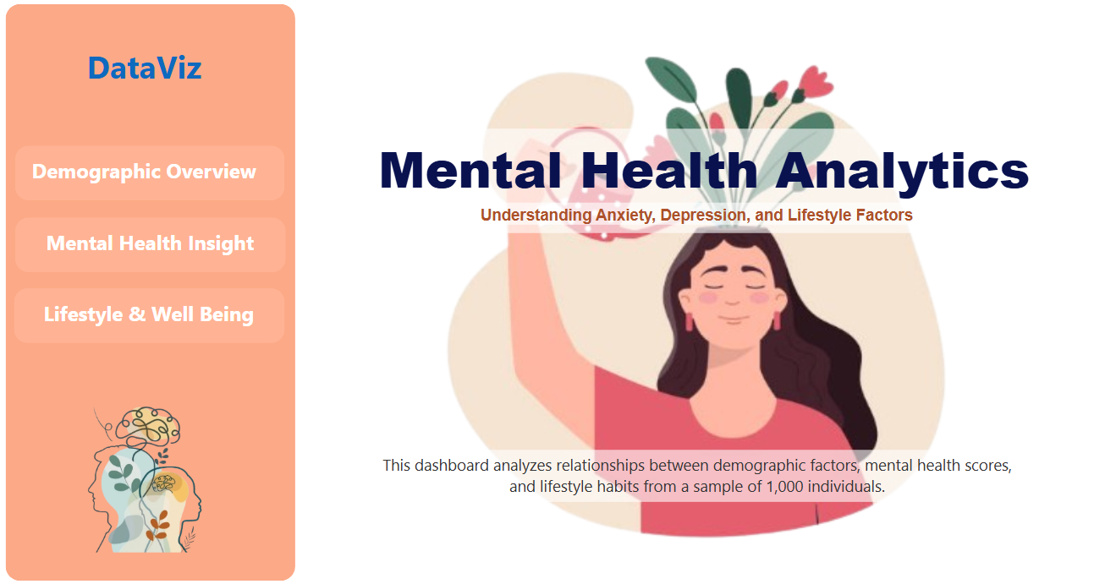

Figure 1 – Main Page

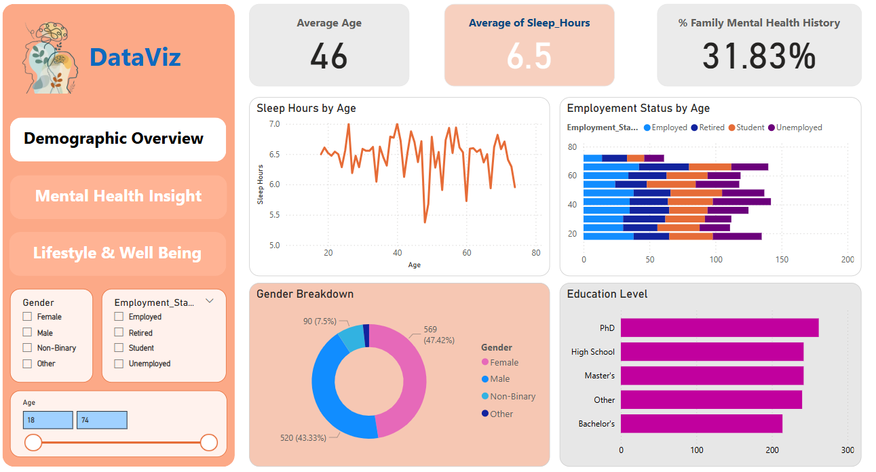

Figure 2 – Page 2 Demographic Overview

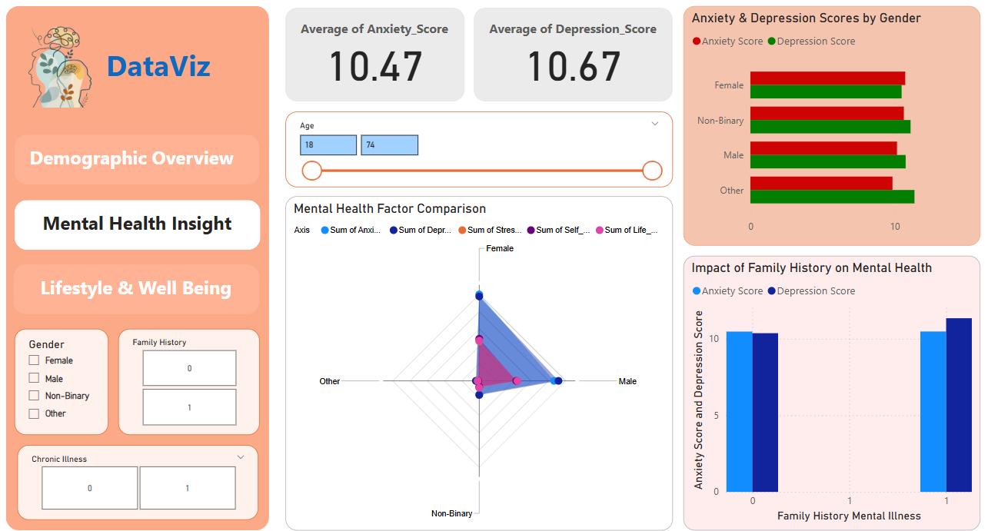

Figure 3 – Page 3 Mental Health Insight

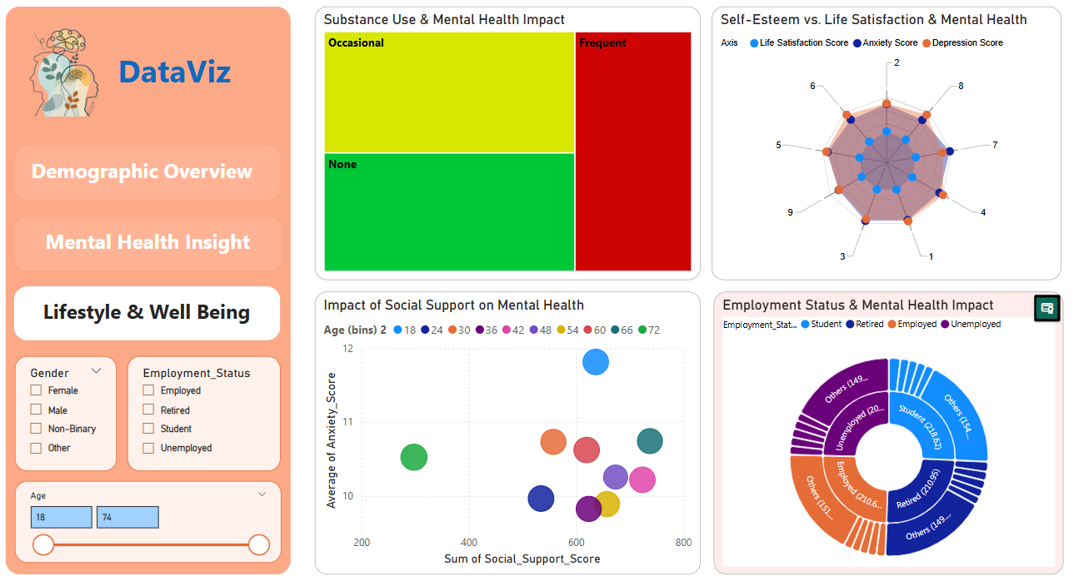

Figure 4 – Page 4 Lifestyle & Well Being